RESEARCH PROJECT: The Smart Bra: Enabling Rapid and Simple Breast Cancer Screening
Breast cancer is a leading cause of cancer mortality among women, with early detection being vital for improving survival rates¹. However, current screening methods still have barriers in terms of accessibility, affordability and comfort^{2,3}. These limitations often lead to delays in detection particularly for women without regular access to medical imaging services.
There is clear need for an affordable, user friendly and non-invasive alternative that enables routine self-checks at home. This proposed project aims to address this need by developing a smart bra embedded with soft stretchable bioimpedance sensors that allow for frequent, convenient monitoring of breast tissue. The goal is to empower women with an accessible method for early detection, bridging healthcare gaps. This project builds on Dr De Leon Vergara’s ongoing research in wearable bioelectronic sensing technologies and established collaborations with clinical partners including BreastScreen Victoria and LifePool at the Peter MacCallum Cancer Centre. The project also enhanced by a currently enrolled PhD student working on bioimpedance-based sensing systems, ensuring the technical capacity to deliver the proposed work. The specific aims of this project are:
Aim 1. To collect breast tissue bioimpedance measurements from participants undergoing routine mammography screening.
Aim 2. To characterise the electrical properties of breast tissue and determine whether bioimpedance signatures correlate with mammographic breast density classifications.
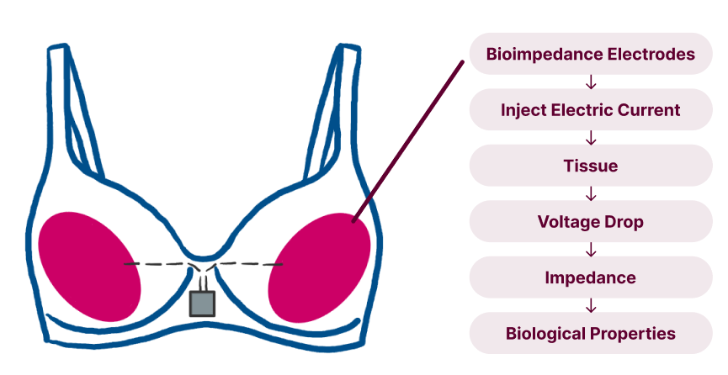
Background
Women living in remote and regional areas often face significant barriers in accessing timely, high-quality healthcare. Breast cancer is one of the leading causes of cancer-related deaths among women worldwide, and early detection is critical for improving survival¹. However, women without easy access to state-of-the-art clinics and diagnostic imaging facilities are at greater risk of late diagnoses, when treatment becomes more difficult, and survival rates decline. This project aims to bridge this gap by developing a smart bra that can provide a low-cost, comfortable, and accessible early warning system for breast cancer, potentially saving lives by catching cancer earlier, even at rural areas.
Figure 1. Smart Bra: bioimpedance Sensing Workflow
Breast cancer accounts for approximately 25% of all cancer cases in women globally, with over two million new cases reported annually¹. While mammography and genetic testing remain the standard tools for early detection, they are not always accessible, comfortable, or affordable. Mammography requires specialised equipment and causes discomfort due to breast compression, leading some women to avoid regular screenings. Moreover, mammography is less sensitive in women with dense breast tissue, increasing the risk of false negatives⁴. Genetic testing identifies individuals at elevated risk but is expensive and not designed for routine monitoring.
Despite these available tools, to the best of my knowledge there is no non-invasive, low-cost, home or GP based method for regular breast cancer screening. This project proposes the development of a smart bra that embeds bioimpedance electrodes directly into the bra’s structure, enabling women to monitor changes in breast tissue themselves, with minimal discomfort and no radiation exposure. Importantly, this technology would allow women living in remote communities to perform routine screenings without needing access to a hospital or imaging centre, offering a new pathway for earlier intervention and better outcomes. Bioimpedance is a non-invasive technique that measures how electrical current passes through tissue, providing information on its structure and composition. Cancerous tissues as it is more dense exhibit distinct electrical signatures compared to healthy tissues, making bioimpedance a potential tool for early cancer detection^{5–7}. These differences are due to changes in cellular structure, extracellular fluid composition, and tissue density. This has underpinned bioimpedance measurements may provide a sensitive method for detecting early pathological changes. While bioimpedance is already used in wearable devices like smartwatches for health assessments, this project will adapt the technology for periodic breast health monitoring. Integrating this method into a stretchable, conductive fabric bra could revolutionize breast cancer screening by improving comfort and usability while removing key psychological and logistical barriers. Figure 1 demonstrates the overall concept of the proposed smart bra, highlighting the workflow of electrodes measuring breast tissue impedance and analysing voltage response to monitor biological properties.
We have established a collaboration with BreastScreen Victoria and LifePool at Peter Mac, with both parties supporting the initiative. Current screening methods for breast cancer are limited to self-examination (palpation) and mammography. While self-examination can be useful, it is a significant source of anxiety and misdiagnosis. Furthermore, BreastScreen Victoria has advised us that mammography is only available and recommended for women over 50; however, in recent years, an increasing number of younger women are being diagnosed. Therefore, there is a pressing need for a cheap, comfortable, and easily accessible screening tool.
Research Plan
A PhD student has already begun working on this project, meaning it is ready to start with both personnel and space in place. To kickstart this project, we plan to gather electrical data from the breast. Recent studies have found that there are four breast tissue types⁴, with Type IV (dense tissue) having a higher incidence of breast cancer. We have begun the ethics approval process at St Vincent's Hospital and plan to conduct the recordings in the Faraday cages at the Aikenhead Centre for Medical Discovery (ACMD). LifePool has offered to assist with participant recruitment; these are women who have already consented to share their data for research purposes. We will be able to correlate the electrical data gathered from the breast with the mammography results from their routine screening.
The first phase of the project will be to finalise the ethics application and recruit participants; we anticipate this will be completed by June this year. The second phase involves gathering data from participants and correlating it with their mammography results. We aim on recruiting approximately 30–50 participants, providing sufficient data to explore relationships between electrical bioimpedance measurements and mammographic breast density classifications. Bioimpedance measurements will be collected across a range of frequencies to capture variations in tissue electrical properties, and statistical analysis will be used to evaluate correlations between impedance parameters and breast tissue type. The funds obtained through this grant will support participant recruitment as well as the purchase of consumables: electrodes for recording the electrical properties of the breast.
Expected Outcomes
At the end of this project, we will have obtained electrical data from the breasts of multiple participants. This will form the basis for the later development of a bra for breast cancer screening. Gathering baseline data from the breast is fundamental to developing a good understanding of the different electrical properties of breast tissue and the ideal positioning of electrodes. Furthermore, we expect that the data collected, once correlated with the respective mammography results, can be published, contributing to the fields of breast cancer research and biomedical devices. It will also support strengthening of our current collaboration with LifePool.
References
1. Breast cancer. https://www.who.int/news-room/fact-sheets/detail/breast-cancer. 2. Mansouri, S., Alhadidi, T. & Azouz, M. Ben. Breast Cancer Detection Using Low-Frequency Bioimpedance Device. Breast Cancer : Targets and Therapy 12, 109 (2020). 3. Shah, C. et al. Bioimpedance spectroscopy for breast cancer-related lymphedema assessment: clinical practice guidelines. Breast Cancer Res. Treat. 198, 1–9 (2023). 4. Dense Breasts: Answers to Commonly Asked Questions - NCI. https://www.cancer.gov/types/breast/screening/dense-breasts. 5. De León, S. E., Pupovac, A. & McArthur, S. L. Three-Dimensional (3D) cell culture monitoring: Opportunities and challenges for impedance spectroscopy. Biotechnology and Bioengineering vol. 117 1230–1240 (2020). 6. Mirhoseini, M., Gatabi, Z. R., Das, S., Joveini, S. & Gatabi, I. R. Applications of Electrical Impedance Tomography in Neurology. Basic Clin. Neurosci. 13, 595–607 (2022).7. Ceres, D. M., Mikkelson, W. M., Gregory, C. W., Marx, J. J. & Gregory, W. D. Bioelectrical Impedance Analysis for Breast Cancer: Diagnosis, Prognosis, and Tissue Mapping. Med. Res. Arch. 13, (2025).
PROJECT ALIGNMENT WITH UN SUSTAINABLE DEVELOPMENT GOALS
This project aligns with UN Sustainable Development Goal 3: Good Health and Well-Being, which prioritises reducing premature mortality from non-communicable diseases such as cancer through improved early detection and prevention strategies. Cancer is best treated when caught early; however, marginalised communities often lack access to specialised equipment. It is therefore fundamental to develop a low-cost, easy-to-use device for breast cancer screening. This proposal contributes to the development of such a device, while also reducing inequalities by empowering women to take control of their own health. The project also contributes to SDG 10: Reduced Inequalities by supporting the development of a low-cost screening technology that could improve access to breast health monitoring for women in remote or underserved communities.
PROJECT ALIGNMENT WITH ENABLING IMPACT PLATFORMS
This project aligns with two of the Enabling Impact Platforms: Advanced Materials, Manufacturing and Fabrication and Biomedical Health and Innovation. The funds obtained from this grant will serve to gather preliminary data for the fabrication of a flexible wearable device. The proposed system combines flexible conductive textiles, stretchable electrodes, and wearable sensing technologies, representing an emerging class of soft bioelectronic devices that align strongly with the goals of the Advanced Materials, Manufacturing and Fabrication platform. The data obtained will be used towards the monitoring and screening of breast cancer, aligning with Biomedical and Health Innovation EIP. Furthermore, this project solidifies RMIT's position with external collaborators, including LifePool at Peter Mac and the ACMD at St Vincent's Hospital, strengthening RMIT's standing in clinical translation and real-world impact outcomes.

PROJECT SUSTAINABILITY
I supervise a PhD student who is currently working with me on this project, ensuring continuity going forward. The data generated through this project will position the team to pursue larger external funding opportunities, including NHMRC and MRFF schemes, while also supporting ongoing collaboration with clinical partners and potential industry translation pathways.
Furthermore, given my firm belief in the potential of this technology, the preliminary data could also be used to support the establishment of a new company focused on the development of this device. I believe this device has the potential to help hundreds of women around the world who either lack access to specialised imaging or avoid regular checks due to discomfort - a need that has been further validated by experts in the field, including BreastScreen Victoria.

